Socioeconomic & Housing Predictors for Burglary by City in Arizona
Chapter 5

Landon Pillar
Mesa Community College
CIS 480
4/30/2026

Summary of Hypothesis and Results:
This study had the goal of determining whether certain socioeconomic factors could significantly predict burglary rates across cities in Arizona. The primary variables included poverty rate, employment rate, vacancy rate, single parent household rate, youth enrollment rate, and the city population. The dependent variable was burglary rates per 100,000 residents. There were three primary hypotheses that were tested:

Hypothesis 1: Poverty Rate and Burglary Rates
- H₀: Poverty rate has no statistically significant relationship with burglary rates
- H₁: Higher poverty rates are associated with higher burglary rates
Result: Not rejected
PowerBI visualizations were made which analyzed and showed an upward trend between poverty rate and burglary rates, indicating that cities that had higher poverty typically tended to experience a higher rate of burglaries. However, it is important to note that when a linear regression was performed based on all factors the model failed to capture the relationship effectively (R² = -0.2068) , this suggests that all the proposed variables for burglary rates are not strictly linear. The Random Forest model had an R² of 0.3864 which provided stronger evidence that poverty and other variables contribute just in a more complex and nonlinear way.
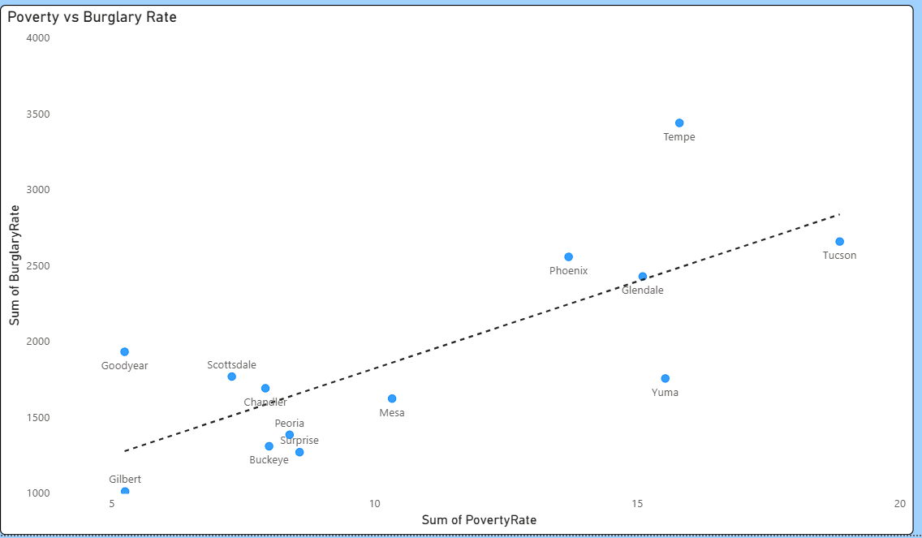

Hypothesis 2: Unemployment Rate and Burglary Rates
- H₀: Unemployment rate has no statistically significant effect on burglary rates
- H₁: Higher unemployment rates are associated with higher burglary rates
Result: Not Rejected
Visualizations again show a strong correlation and positive trend between unemployment and burglary rates though is slightly less than the poverty rate.
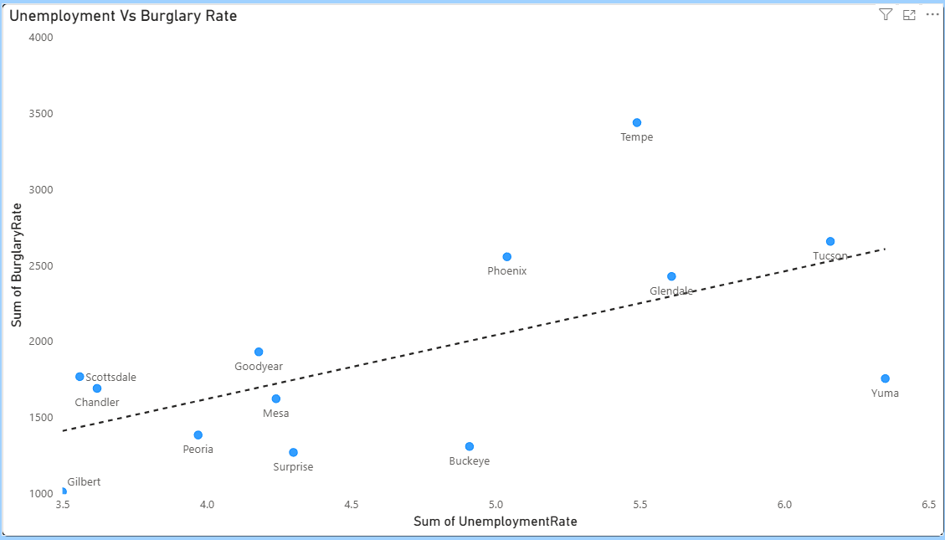

Hypothesis 3: Vacancy Rate and Burglary Rates
- H₀: Vacancy rate has no statistically significant relationship with burglary rates
- H₁: Higher vacancy rates are associated with higher burglary rates
Result: Not rejected, but weakly supported
Vacancy did show a slight positive relationship with burglary rates, though the trend was not strong at all. This aligns with prior theories that vacant properties may increase crime opportunities, but the impact may be fairly limited.
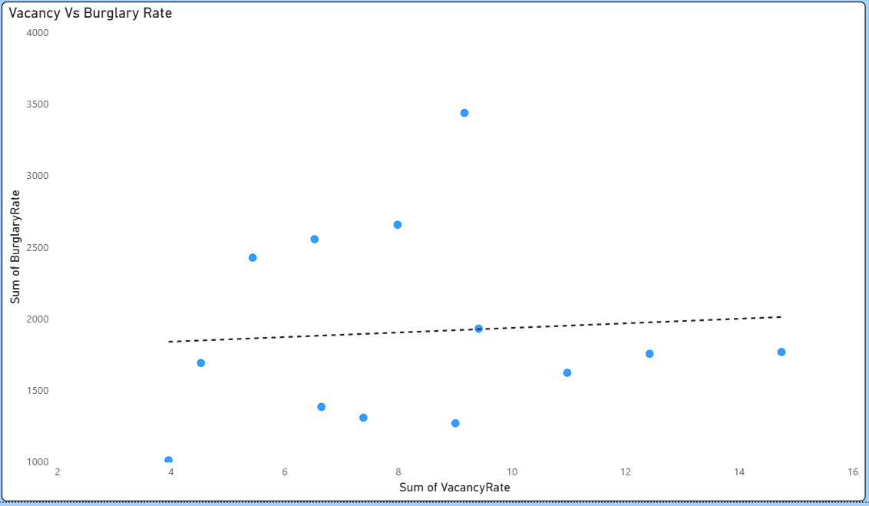
Project Summary and Reflection:
This project successfully demonstrated the application of data analysis techniques to a real world public safety problem. Using publicly available data from PolicyMap, multiple datasets were cleaned and merged then analyzed to examine the relationship between socioeconomic conditions and burglary rates across the highest population Arizona cities.
One of the most important findings for this project was seeing the difference between visual analysis and statistical modeling. The overall modeling showed weak relationships between all socioeconomic variables as a whole, but creating visualizations showed insights into what factors did and did not play a large role in predicting or making connections to burglary rates.
The key findings of the project were that poverty, unemployment, and youth enrollment all showed key impacts on burglary rates. Vacancy had a positive correlation though it was limited, and single parent households showed little to no correlation whatsoever. Several challenges were encountered when it came to scaling this project, with the initial idea being to look even deeper into zipcode based data. This became a problem though as there was not enough data for specific zipcodes to make insightful conclusions, so I had to settle for city level data. Another problem had to do with having limited visual representation as the best way to show trends related to my topic was to use scatter charts as the data was not time based.
Throughout this project, skills like data cleaning, exploratory analysis, statistical modeling, and visualizations were used. This experience helped to reinforce the importance of combining multiple different approaches to create a complete understanding of a specific problem. Moving forward, I will continue to practice these skills and apply them to more advanced datasets.
Real-World Implications:
The findings made in this project can have large important implications when connected to public safety, urban planning, and community development. By being able to identify the socioeconomic factors that are associated with high burglary rates, this analysis contributes to a better understanding of how the structural conditions can influence crime.
One key factor is the role of poverty, unemployment, and economic disadvantage shaping crime patterns. The result showed that cities with higher levels of poverty typically tended to have higher burglary rates. This indicates that addressing poverty through economic programs, job creation, and access to certain services or resources could help reduce poverty crime in big cities. The findings also found that when youth are out of school, burglary rates tend to increase. This means that ensuring students have access to schools and an education can help potentially decrease the burglary rate, at least among young offenders. A real world way to solve this would be to ensure that the youth are able to have transportation to school and that schools are located in areas that have students needing a place to be educated.
The other factor that showed a slight correlation was vacancy rates. Even though it was relatively weak, certain improvements can be made such as creating affordable housing and creating policies to reduce housing vacancy like improved property management could help minimize burglaries even if it is less impactful.
From a policy perspective, this analysis helps demonstrate that crime prevention should not be solely focused by law enforcement, but also on improving the socioeconomic factors that lead to these crimes occurring in the first place. Investments into things like education, housing stability, and economic development can have major long term benefits and effects in reducing crime rates.
Conclusion:
This study set out to determine what factors could predict burglaries across Arizona cities. The results indicate that while these variables do have influence on burglary rates, the relationships themselves are complex and as a whole cannot be fully explained with a simple linear model. The poor performance of the regression model demonstrates that burglary rates are not as straightforward but are more complicated and that some factors may play a large role while others play little.
Overall, the findings support the general idea and premise of social disorganization theory, which argues that community level disadvantages lead to higher crime rates. However, the analysis shows that these effects are not uniform and can vary across cities.
To conclude, certain socioeconomic conditions do play a role in shaping burglary rates, but their impact can differentiate. Future research should incorporate larger datasets, more variables, and perhaps specific global events which may lead to worse economic outcomes.

